# CS 255 System Design Document Template

## UML Diagrams

### UML Use Case Diagram

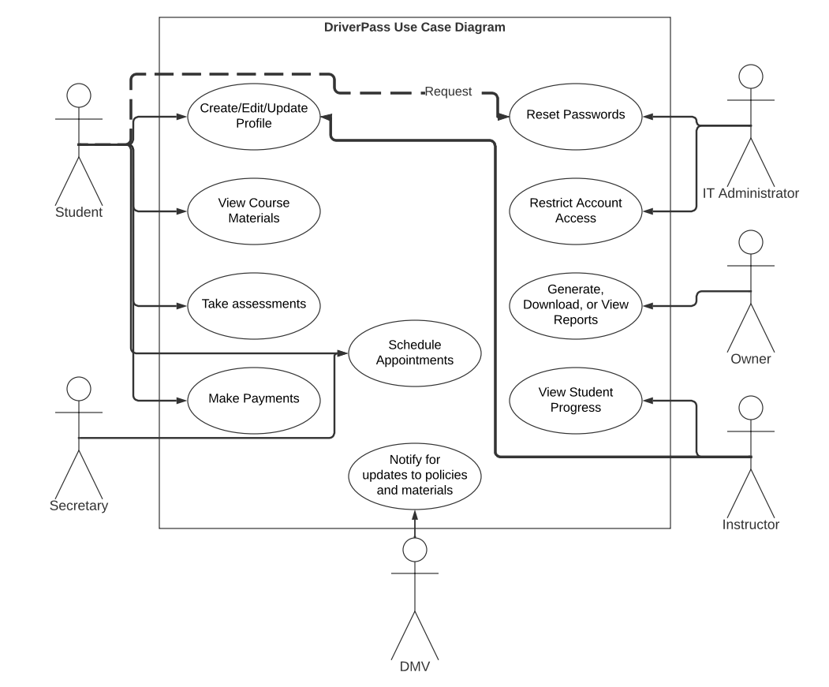

### UML Activity Diagrams

### UML Sequence Diagram

### UML Class Diagram

## Technical Requirements

Infrastructure Required:

* Physical server or Cloud Hosting provider
* Power for computing equipment
* Adequate internet speeds
* Employee parking
* Cars for students/instructors
* Insurance as required by law in state of operations
* Credit card processing contract

Hardware Requirements for Client:

* Desktop, laptop, or mobile device
* Wi-Fi or ethernet connection
* Power source for devices

Software Requirements for Host:

* AWS Web Hosting
* DriverPass Software
* Docker to control Virtual Machine traffic
* Network Security Software to prevent data stealing/hacking

Software Requirements for Client:

* Web browser (Firefox, Chrome, Explorer, etc.)
* Operating System (IOS, Android, Windows, Linux, etc.)

Tools for Development:

* Modern computing equipment
* Internet connection for server usage
* Programs for development (VSCode, Visual Studio, IntelliJ, etc.)